SUMMERVILLE CREDIT UNION · BUSINESS BANKING USER GUIDE · CSUM-11 of 16
Business Alerts
Module: Business Banking > More > Business Alerts
Navigation: Dashboard → Business Banking → More → Business Alerts
Sources: Summerville Reports Series A + Series B | Features: nFinia Documentation Features Spreadsheet
01 PRODUCT SUMMARY

Business Alerts enables business members to configure automated notifications for security events, transaction activity, and account changes across their business accounts. The alert configuration is organized by category: Security and Account Alerts, Wire Alerts, ACH Alerts, and Transfer Alerts. Each category contains individual alert types with toggle switches to enable or disable notifications.
The feature supports a master toggle to enable or disable all business alerts, a Show Enabled Alerts filter, and an Expand All option to view all alert categories simultaneously. The system displays the total count of enabled alerts (e.g., 10/18 Enabled) for quick visibility into the current notification configuration.
For credit unions, business alerts are a proactive security and engagement tool. They keep business members informed of account activity in real-time, reducing the window for fraud detection and increasing member confidence in the platform.
At a Glance
Attribute | Detail
Feature Name | Business Alerts
Module | Business Banking > More > Business Alerts
Navigation | Dashboard → Business Banking → More → Business Alerts
User Roles | Business Owner, Authorized Signer, Business Admin
Access Level | Role-based; available to users with alert configuration permission
Key Actions | Enable/Disable alerts by category, Toggle individual alerts, Expand/Collapse categories
Regulatory Relevance | Fraud detection support, Regulation E notification compliance

02 KEY USE CASES

Use Case | Who Uses It | What They Do | Business Value
Enable Security Alerts | Business Owner | Turn on all security and account change notifications | Immediate awareness of unauthorized access attempts
Configure Wire Alerts | Authorized Signer | Enable alerts for wire transfer activity | Real-time notification of high-value wire movements
ACH Activity Monitoring | Business Admin | Set alerts for ACH debits and credits | Monitors automated payment activity for anomalies
Disable Non-Critical Alerts | Business Owner | Turn off low-priority alerts to reduce noise | Customizes notification volume to business preferences

03 STEP-BY-STEP USER GUIDE

How to get here: Dashboard → Business Banking → More → Business Alerts
Step 1: Log In and Open the Dashboard
Open your web browser and navigate to the Summerville Credit Union digital banking platform. Enter your username and password on the login screen and click "Log In." If prompted, complete the OTP (One-Time Passcode) verification by entering the code sent to your registered device. After successful authentication, you will land on the Dashboard — also called the Account Overview screen. This is your home base. The Dashboard displays all your business accounts (Savings Accounts, Checking Accounts) with their available and current balances. The top navigation bar shows links to Dashboard, Accounts, Transfer & Pay, Cards, Business Banking, and More. On the right sidebar you will see Related Links (Change Password, Account Settings, View Scheduled Transfers, Account Specific Alerts) and a Quick Transfer widget for fast internal transfers. To proceed to Business Banking features, locate the "Business Banking" tab in the top navigation bar and click on it.
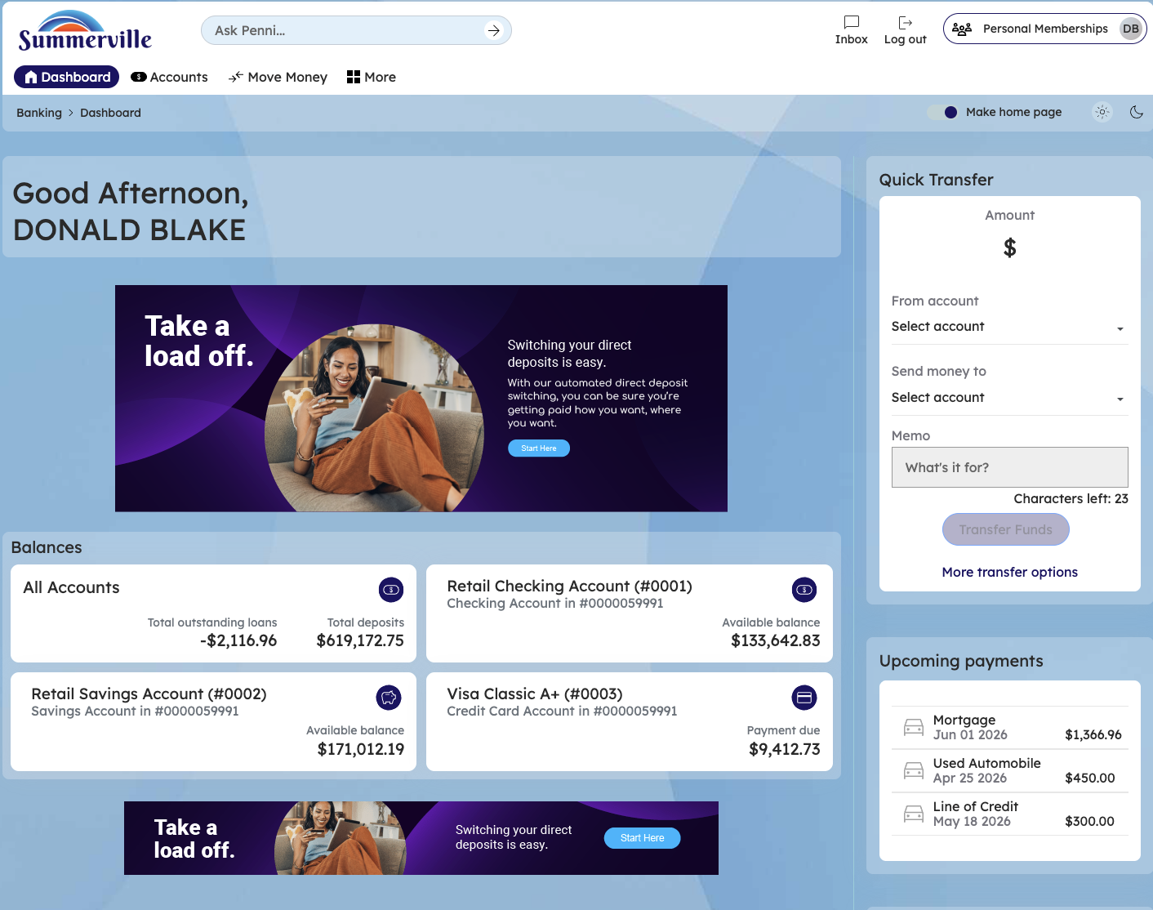
Figure 1 — Log In and Open the Dashboard

Step 2: Open the Business Banking Hub
After clicking "Business Banking" in the top navigation bar, the Business Banking Hub loads. This is the central command center for all commercial banking operations. The Hub is organized into three sections: "Transfers" at the top (with tiles for ACH Transfer, Domestic Wire Transfer, Transfer Template, and Payment From File), "Manage" in the middle (with tiles for Role Management, User Management, Approval Settings, and Recipient Management), and "More Options" at the bottom (with tiles for Commercial Activity, Reports, and Approvals). Each tile is a direct entry point to its corresponding feature. Only tiles your role has permission to access will be visible. From here, locate and click the tile for the feature you need — the next steps will guide you through the specific workflow.
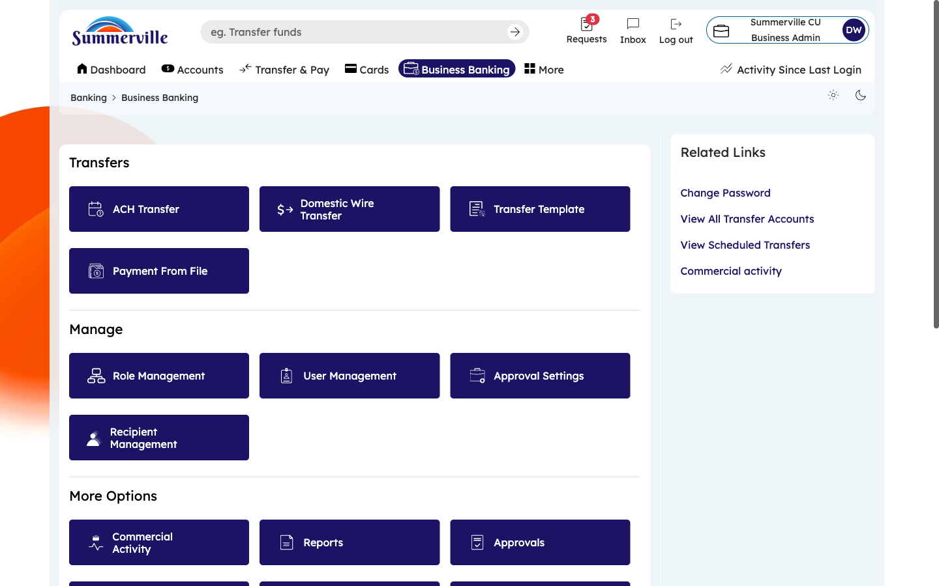
Figure 2 — Open the Business Banking Hub

Step 3: Navigate to Business Alerts
From the Dashboard, click "Business Banking" in the left-side navigation menu to open the Business Banking Hub. Navigate to the Business Alerts feature by clicking More → Business Alerts in the left-side navigation within Business Banking. The Business Alerts page appears. At the top, select the business entity whose alerts you want to configure (if you manage multiple business accounts). You will see a master "Enable" toggle — this is a global on/off switch for all business alerts. The "Show Enabled Alerts" filter (displaying "10/18 Enabled") lets you view only active alerts. Click "Expand All" to open all alert categories at once. The first visible category is "Security and Account Alerts."
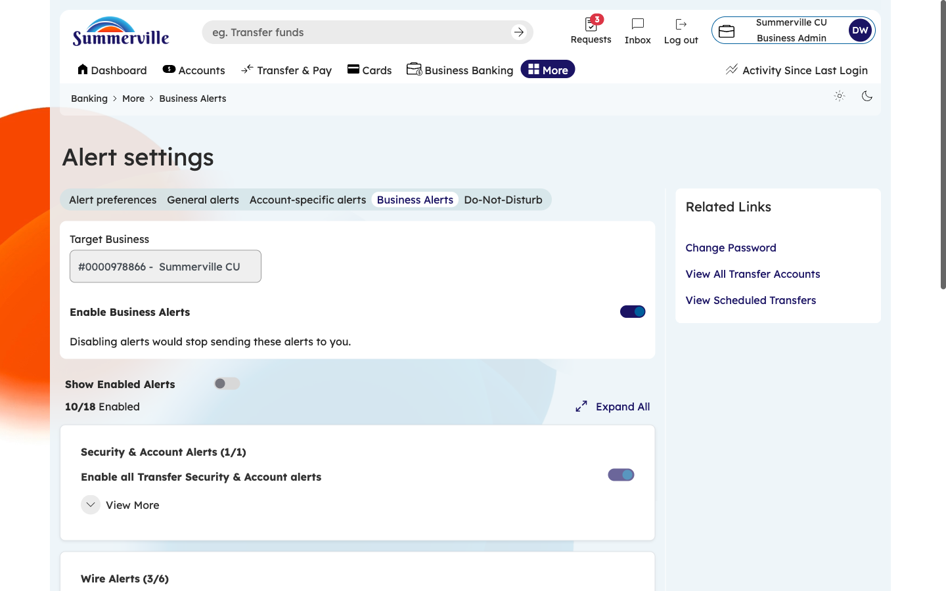
Figure 3 — Navigate to Business Alerts

Step 4: Configure Security and Account Alerts
Click to expand the "Security and Account Alerts" category if it is not already open. You will see individual alert types: Entitlement Changed (when a user's permissions are modified), Password Changed, Login from New Device, Failed Login Attempt, Account Locked, and User Added/Removed. Toggle each alert ON to receive notifications when that event occurs, or OFF to disable it. Recommendation: enable ALL security alerts, as these cover events that could indicate unauthorized access or account compromise. The notifications will be delivered via email, SMS, or in-app based on your contact preferences.
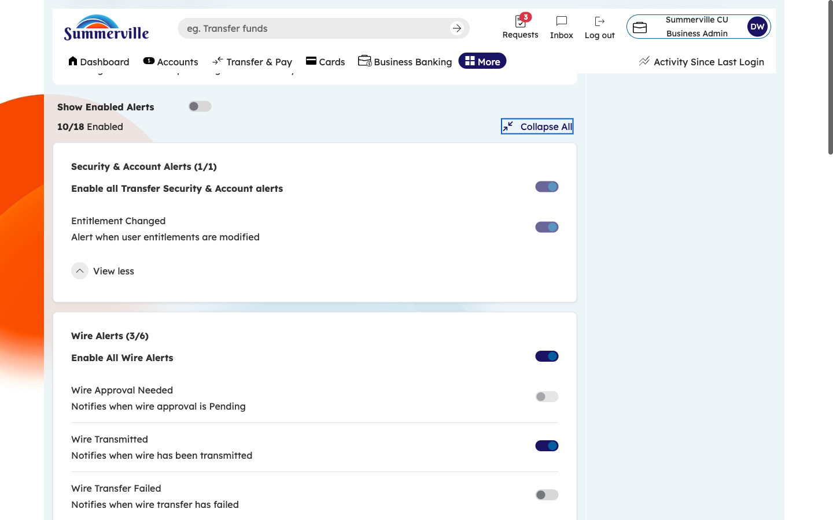
Figure 4 — Configure Security and Account Alerts

Step 5: Configure Wire and ACH Alerts
Scroll down to see the "Wire Alerts" and "ACH Alerts" categories. Expand each category and configure the individual alert toggles. Wire Alerts include: Wire Transfer Initiated, Wire Transfer Approved, Wire Transfer Declined, Wire Transfer Processed, and Wire Transfer Failed. ACH Alerts cover: ACH Payment Sent, ACH Payment Received, ACH Collection Initiated, ACH Batch Processed, and ACH Transaction Failed. Toggle ON the alerts most important to your business operations. For high-volume payment operations, wire alerts are especially critical since wires are irrevocable.
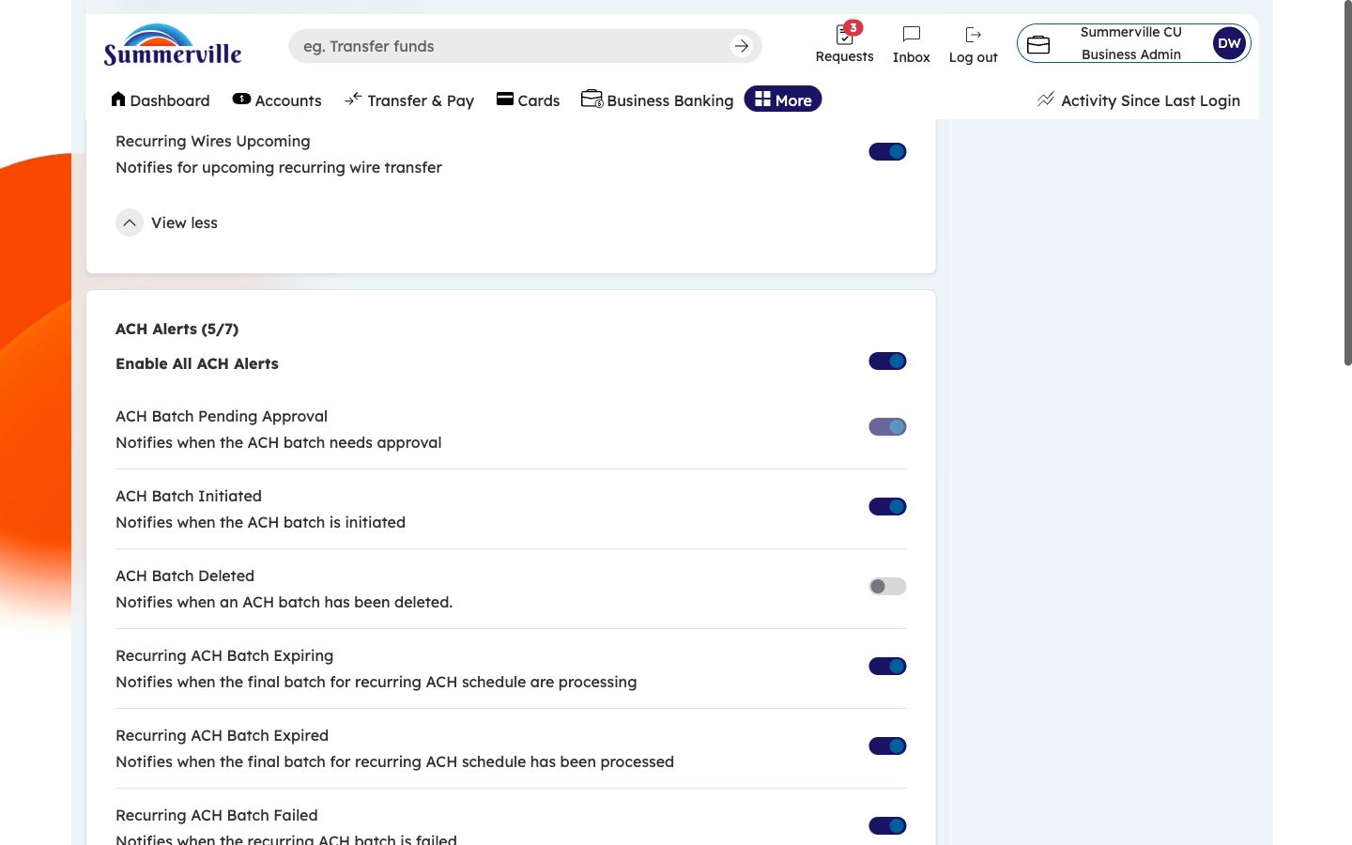
Figure 5 — Configure Wire and ACH Alerts

Step 6: Configure Transfer Alerts and Save
Continue scrolling to the bottom of the page. You will see remaining ACH Alerts and the "Transfer Alerts" category covering internal fund transfers between your credit union accounts. Configure these toggles based on your needs: Internal Transfer Completed, Scheduled Transfer Executed, Transfer Template Run, and Transfer Failed. After configuring all categories, click "Save" to commit your alert settings. The "10/18 Enabled" counter at the top updates in real-time as you toggle alerts on or off, giving you immediate visibility into how many alerts are active.
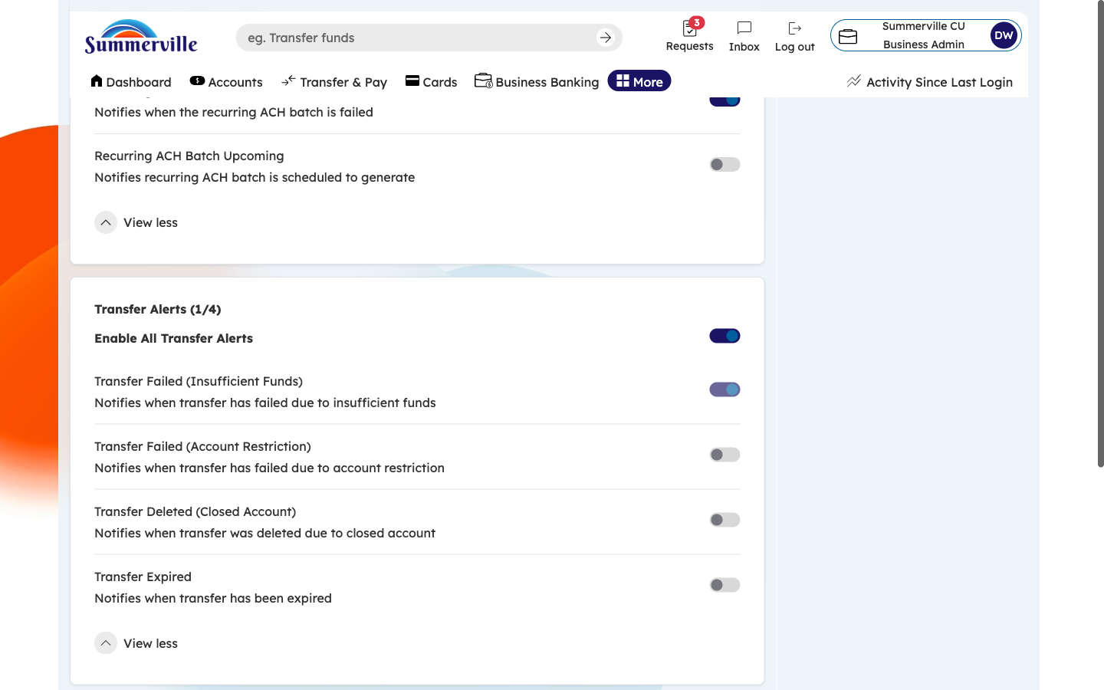
Figure 6 — Configure Transfer Alerts and Save

